SUMMERVILLE CREDIT UNION · CONSOLIDATED MEMBER GUIDE · CSUM-25 of 30
Password, User ID & MFA Settings

Module: nFinia Digital Banking > Settings > User ID & Security
Sources: Summerville Reports Series A (36 docs) + Series B (25 docs) | Features: nFinia Documentation Features Spreadsheet
01 PRODUCT SUMMARY

The Password, User ID & MFA Settings section gives members self-service control over their digital banking login credentials and authentication methods. Members can change their username, update their password, add or remove MFA delivery methods, and review their security configuration — all without contacting the CU.
Changing a User ID requires the new ID to be unique across the platform and may require OTP verification. Password changes require entry of the current password for verification. All credential changes are logged as security events and trigger a notification to the member's registered contact.
MFA Settings allow members to manage which authentication methods are active for their account (SMS OTP, email OTP, authenticator app, biometric), set a primary method, and add or remove methods. At least one active MFA method must remain configured at all times for account security compliance.

At a Glance

Attribute | Detail
Module | Settings > User ID & Password / MFA
User ID Change | Member-initiated username change; requires uniqueness validation
Password Change | Requires current password; complexity rules enforced
MFA Methods | SMS OTP, Email OTP, Authenticator App, Biometric
MFA Requirement | Minimum one active method required at all times
Related Reports | CSUM-01 (Login & Auth), CSUM-23 (Settings), CSUM-28 (Device Management)

02 KEY USE CASES

Use Case | Who Uses It | What They Do | Business Value
Change Username | Members wanting a more memorable login ID | Open User ID Settings, enter new username, confirm | Personalises login without contacting CU support
Update Password | Members rotating credentials for security hygiene | Enter current password, set new password, confirm | Self-service security rotation without calling support
Add MFA Method | Members adding a backup authentication factor | Open MFA Settings, select Add Method, verify, save | Adds resilience if primary MFA device is unavailable
Remove Old MFA Method | Members with an old phone number in MFA | Open MFA Settings, select old method, remove after verifying current method | Keeps authentication methods current with the member's active devices

03 STEP-BY-STEP GUIDE

Navigation: Dashboard > Settings > 'User ID & Password' OR 'MFA Settings'.

Step 1 — Start from Dashboard
The member begins at the Dashboard after logging in. The Dashboard displays all account balances, upcoming payments, quick-action tiles, and the top navigation bar with links to Accounts, Move Money, and More.
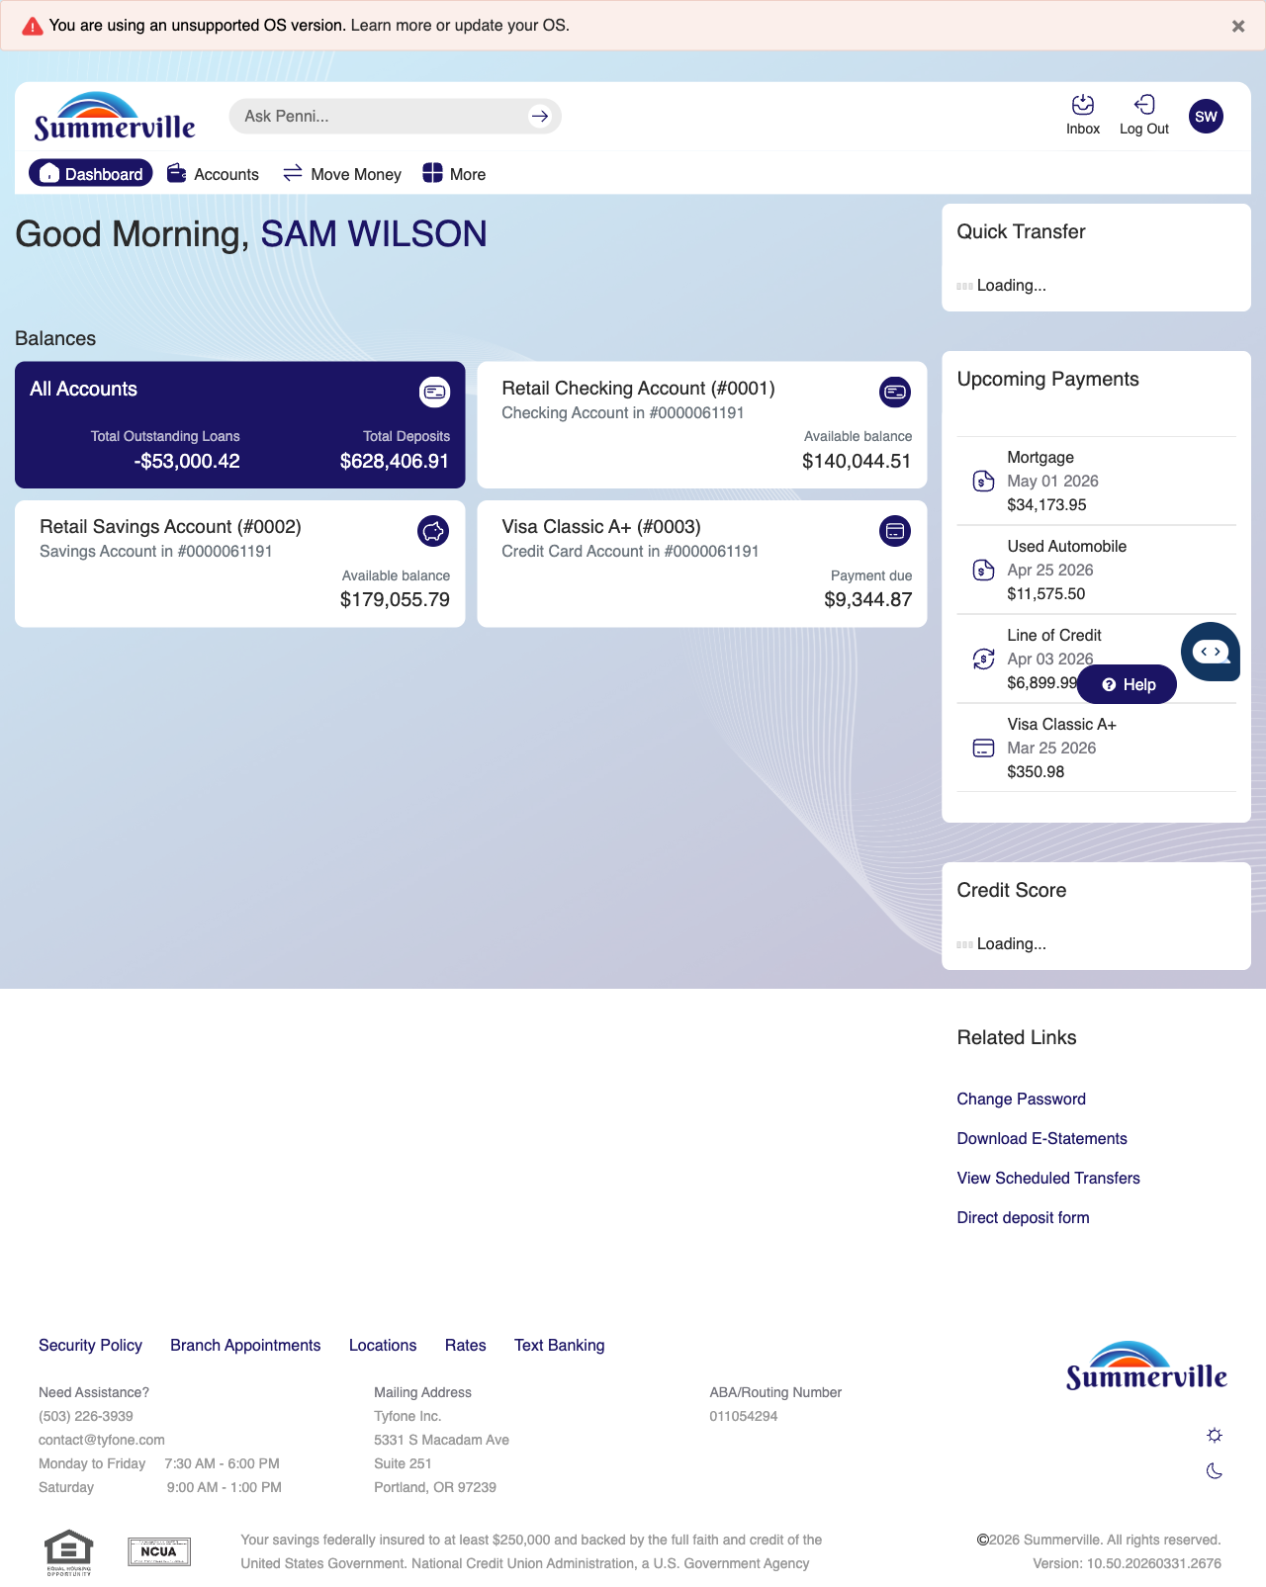
Step 1: Start from Dashboard

Step 2 — Open the More Menu
The member clicks ‘More’ in the top navigation bar. The More options panel expands to show additional features: Check Deposit, User ID and Password, eDocuments, Account Alerts, General Alerts, Password, Forms, One-Time Passcode, Skip A Pay, Do-Not-Disturb, Manage Devices, My Insights, Alert Settings, Recent Activities, and Card Services.
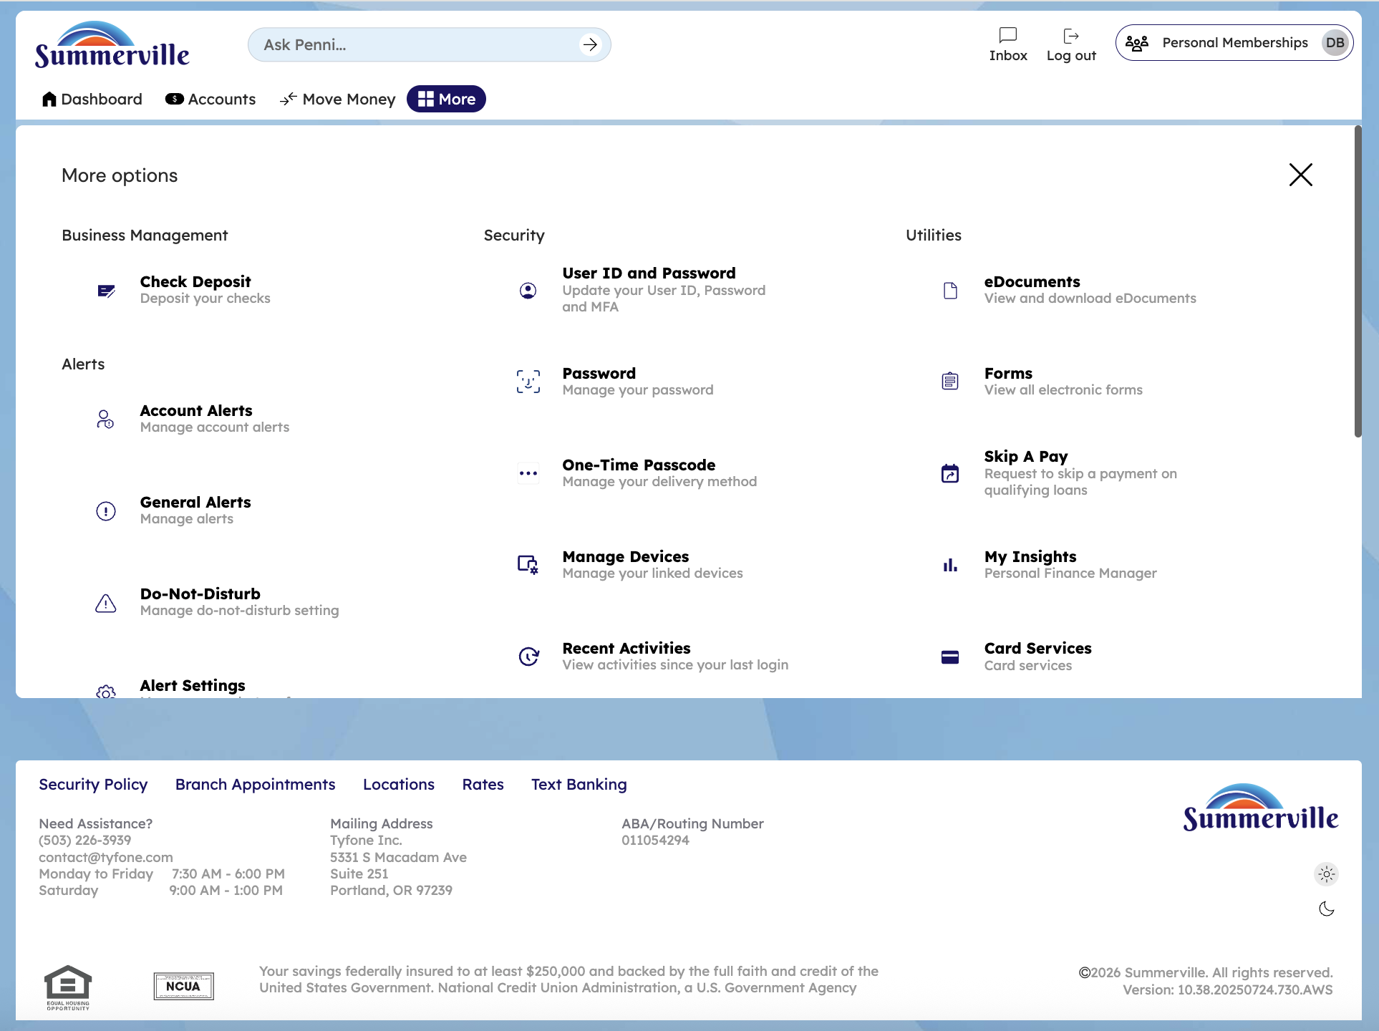
Step 2: More Menu

Step 3 — Navigate from Dashboard to User ID Settings
The User ID and Password Settings page is displayed with tabs for User ID, Password, and Multi-Factor Authentication, allowing the member to manage their login credentials.
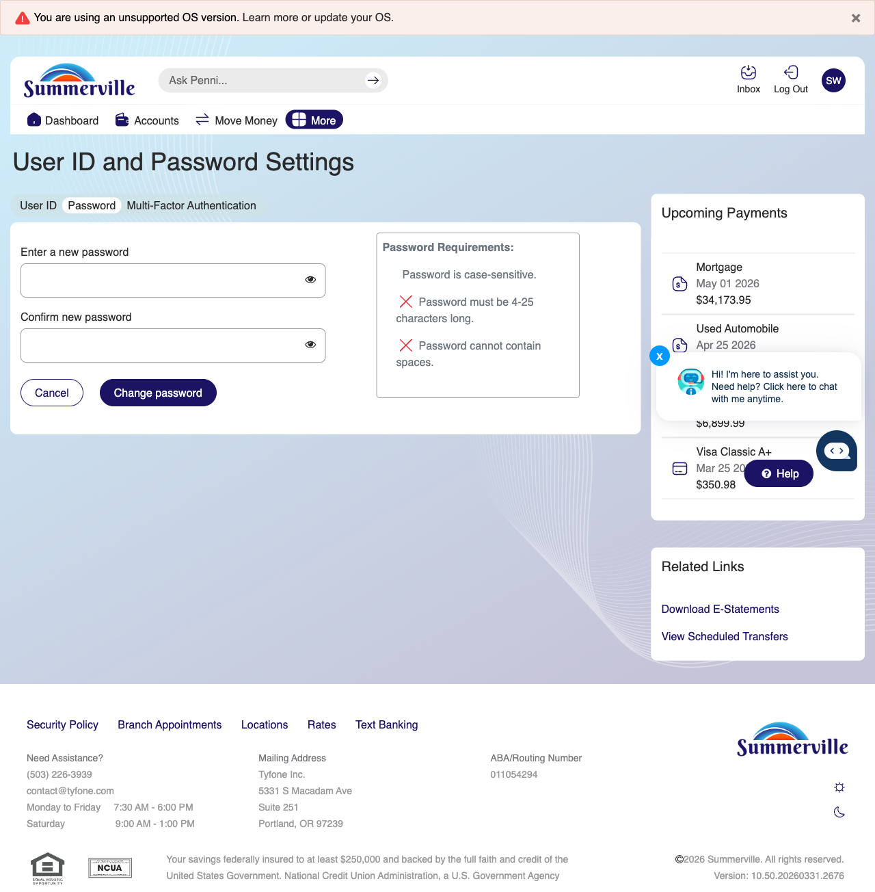
Step 3: Navigate from Dashboard to User ID Settings

Step 4 — Change User ID
The Password change form is shown with 'Enter new password' and 'Confirm new password' input fields along with a list of Password Requirements (minimum length, special characters, etc.).
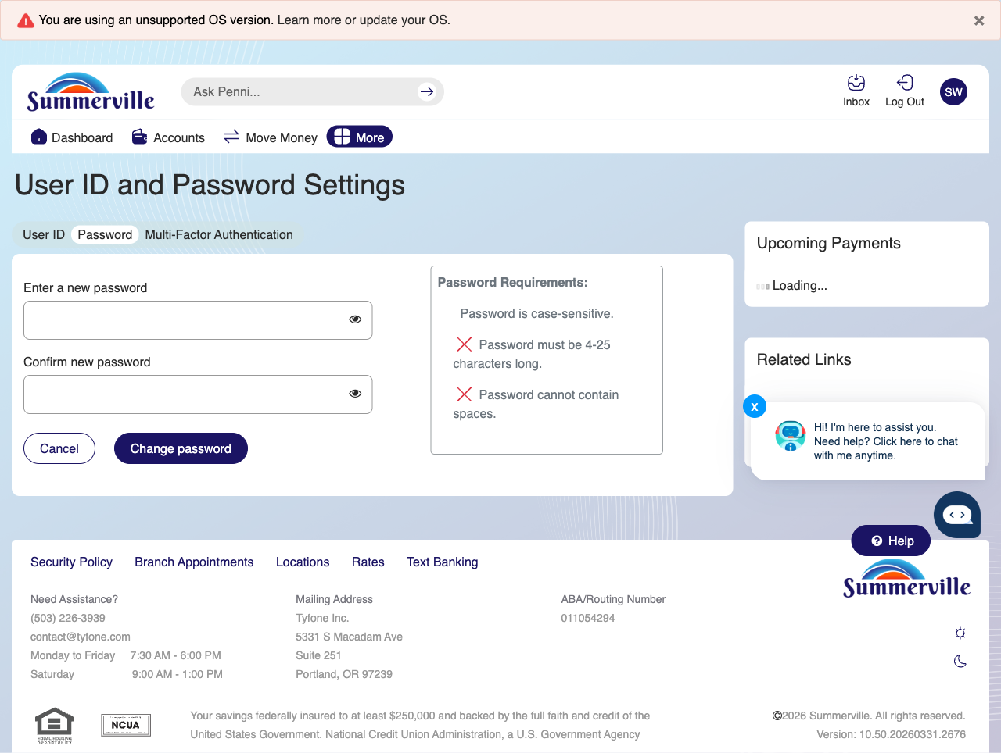
Step 4: Change User ID

Step 5 — Review MFA Preferences
The User ID and Password Settings page shows the Multi-Factor Authentication preferences section where the member can manage their MFA delivery methods.
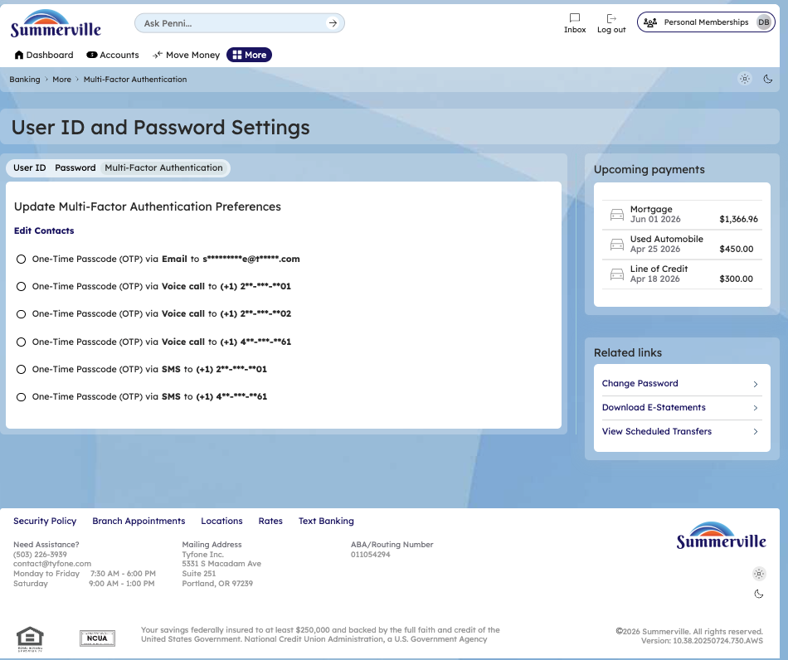
Step 5: Review MFA Preferences

